ASSIGNMENT 9 GRPAHS
1)
#include <iostream>
using namespace std;

class Graph {
int V;
int **adjMatrix;

public:
Graph(int V) {
this->V = V;
adjMatrix = new int*[V];
for (int i = 0; i < V; i++) {
adjMatrix[i] = new int[V];
for (int j = 0; j < V; j++) {
adjMatrix[i][j] = 0;
}
}
}

void addEdge(int u, int v) {
adjMatrix[u][v] = 1;
adjMatrix[v][u] = 1;
}

void removeEdge(int u, int v) {
adjMatrix[u][v] = 0;
adjMatrix[v][u] = 0;
}

int degreeIn(int vertex) {
int count = 0;
for (int i = 0; i < V; i++) {
if (adjMatrix[i][vertex] == 1) count++;
}
return count;
}

int degreeOut(int vertex) {
int count = 0;
for (int i = 0; i < V; i++) {
if (adjMatrix[vertex][i] == 1) count++;
}
return count;
}

void adjacentVertices(int vertex) {
cout << "Adjacent vertices to " << vertex << ": ";
for (int i = 0; i < V; i++) {
if (adjMatrix[vertex][i] == 1) {
cout << i << " ";
}
}
cout << endl;
}

int numberOfEdges() {
int count = 0;
for (int i = 0; i < V; i++) {
for (int j = i + 1; j < V; j++) {
if (adjMatrix[i][j] == 1) count++;
}
}
return count;
}

void displayGraph() {
cout << "Adjacency Matrix:" << endl;
for (int i = 0; i < V; i++) {
for (int j = 0; j < V; j++) {
cout << adjMatrix[i][j] << " ";
}
cout << endl;
}
}
};

int main() {
int V, choice, u, v;
cout << "Enter the number of vertices: ";
cin >> V;
Graph g(V);

do {
cout << "\nMenu:\n";
cout << "1. Add edge\n";
cout << "2. Remove edge\n";
cout << "3. Degree In\n";
cout << "4. Degree Out\n";
cout << "5. Adjacent Vertices\n";
cout << "6. Number of edges\n";
cout << "7. Display graph\n";
cout << "8. Exit\n";
cout << "Enter your choice: ";
cin >> choice;

switch (choice) {
case 1:
cout << "Enter the vertices to add edge (u v): ";
cin >> u >> v;
g.addEdge(u, v);
break;

case 2:
cout << "Enter the vertices to remove edge (u v): ";
cin >> u >> v;
g.removeEdge(u, v);
break;

case 3:
cout << "Enter vertex to find degree in: ";
cin >> u;
cout << "Degree In: " << g.degreeIn(u) << endl;
break;

case 4:
cout << "Enter vertex to find degree out: ";
cin >> u;
cout << "Degree Out: " << g.degreeOut(u) << endl;
break;

case 5:
cout << "Enter vertex to find adjacent vertices: ";
cin >> u;
g.adjacentVertices(u);
break;

case 6:
cout << "Number of edges: " << g.numberOfEdges() << endl;
break;

case 7:
g.displayGraph();
break;

case 8:
cout << "Exiting program.\n";
break;

default:
cout << "Invalid choice. Please try again.\n";
}
} while (choice != 8);

return 0;
}

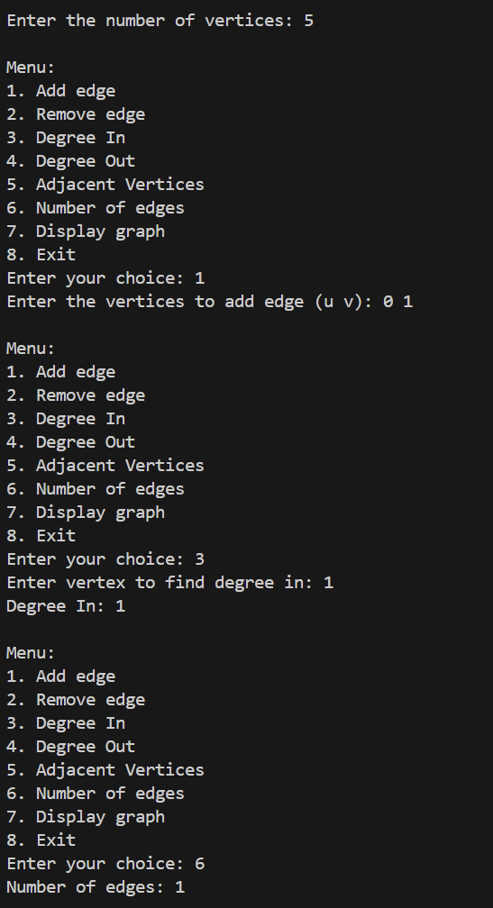
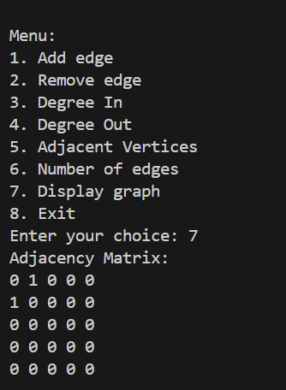

2)
#include <iostream>
using namespace std;

class Graph {
public:
int V;
int adjMatrix[10][10];

Graph(int V);
void addEdge(int u, int v);
void BFS(int start);
};

Graph::Graph(int V) {
this->V = V;
for (int i = 0; i < V; i++) {
for (int j = 0; j < V; j++) {
adjMatrix[i][j] = 0;
}
}
}

void Graph::addEdge(int u, int v) {
adjMatrix[u][v] = 1;
adjMatrix[v][u] = 1;
}

void Graph::BFS(int start) {
bool visited[10] = { false };
int queue[10];
int front = 0, rear = 0;

visited[start] = true;
queue[rear++] = start;

while (front < rear) {
int node = queue[front++];

cout << node << " ";

for (int i = 0; i < V; i++) {
if (adjMatrix[node][i] == 1 && !visited[i]) {
visited[i] = true;
queue[rear++] = i;
}
}
}
}

int main() {
int vertices, edges;
cout << "Enter number of vertices: ";
cin >> vertices;

Graph g(vertices);

cout << "Enter number of edges: ";
cin >> edges;

cout << "Enter edges (u v) format: " << endl;
for (int i = 0; i < edges; i++) {
int u, v;
cin >> u >> v;
g.addEdge(u, v);
}

int start;
cout << "Enter starting node for BFS: ";
cin >> start;

cout << "BFS starting from node " << start << ": ";
g.BFS(start);

return 0;
}
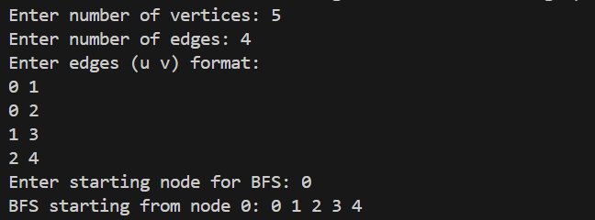

3)
#include <iostream>
using namespace std;

class Graph {
public:
int V;
int adjMatrix[10][10];

Graph(int V);
void addEdge(int u, int v);
void DFS(int start);
void DFSUtil(int start, bool visited[]);
};

Graph::Graph(int V) {
this->V = V;
for (int i = 0; i < V; i++) {
for (int j = 0; j < V; j++) {
adjMatrix[i][j] = 0;
}
}
}

void Graph::addEdge(int u, int v) {
adjMatrix[u][v] = 1;
adjMatrix[v][u] = 1;
}

void Graph::DFSUtil(int start, bool visited[]) {
visited[start] = true;
cout << start << " ";

for (int i = 0; i < V; i++) {
if (adjMatrix[start][i] == 1 && !visited[i]) {
DFSUtil(i, visited);
}
}
}

void Graph::DFS(int start) {
bool visited[10] = { false };
cout << "DFS starting from node " << start << ": ";
DFSUtil(start, visited);
}

int main() {
int vertices, edges;
cout << "Enter number of vertices: ";
cin >> vertices;

Graph g(vertices);

cout << "Enter number of edges: ";
cin >> edges;

cout << "Enter edges (u v) format: " << endl;
for (int i = 0; i < edges; i++) {
int u, v;
cin >> u >> v;
g.addEdge(u, v);
}

int start;
cout << "Enter starting node for DFS: ";
cin >> start;

g.DFS(start);

return 0;
}
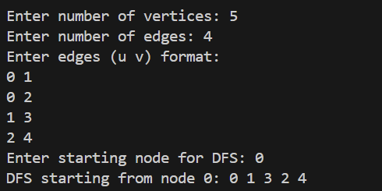

4)
#include <iostream>
using namespace std;

class DisjointSet {
public:
int *parent, *rank;
int n;

DisjointSet(int n) {
this->n = n;
parent = new int[n];
rank = new int[n];
for (int i = 0; i < n; i++) {
parent[i] = i;
rank[i] = 0;
}
}

int find(int u) {
if (parent[u] != u) {
parent[u] = find(parent[u]);
}
return parent[u];
}

void unionSets(int u, int v) {
int rootU = find(u);
int rootV = find(v);

if (rootU != rootV) {
if (rank[rootU] > rank[rootV]) {
parent[rootV] = rootU;
} else if (rank[rootU] < rank[rootV]) {
parent[rootU] = rootV;
} else {
parent[rootV] = rootU;
rank[rootU]++;
}
}
}
};

class Graph {
public:
int V, E;
int **edges;

Graph(int V, int E) {
this->V = V;
this->E = E;
edges = new int*[E];
for (int i = 0; i < E; i++) {
edges[i] = new int[3];
}
}

void addEdge(int i, int u, int v, int weight) {
edges[i][0] = u;
edges[i][1] = v;
edges[i][2] = weight;
}

void kruskalMST() {
DisjointSet ds(V);

for (int i = 0; i < E - 1; i++) {
for (int j = i + 1; j < E; j++) {
if (edges[i][2] > edges[j][2]) {
for (int k = 0; k < 3; k++) {
int temp = edges[i][k];
edges[i][k] = edges[j][k];
edges[j][k] = temp;
}
}
}
}

int mstWeight = 0;
cout << "Edges in MST: " << endl;
for (int i = 0; i < E; i++) {
int u = edges[i][0];
int v = edges[i][1];
int weight = edges[i][2];

int rootU = ds.find(u);
int rootV = ds.find(v);

if (rootU != rootV) {
cout << u << " - " << v << " with weight " << weight << endl;
mstWeight += weight;
ds.unionSets(u, v);
}
}
cout << "Weight of MST: " << mstWeight << endl;
}
};

int main() {
int V, E;
cout << "Enter number of vertices: ";
cin >> V;
cout << "Enter number of edges: ";
cin >> E;

Graph g(V, E);

cout << "Enter edges (u v weight): " << endl;
for (int i = 0; i < E; i++) {
int u, v, weight;
cin >> u >> v >> weight;
g.addEdge(i, u, v, weight);
}

g.kruskalMST();

return 0;
}
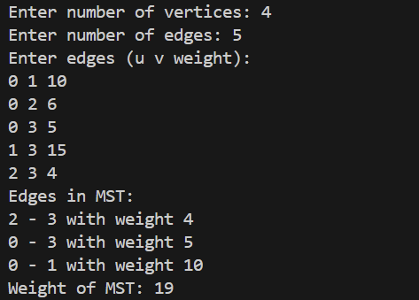

5)
#include <iostream>
using namespace std;

#define INF 99999 // Define a large number to represent infinity

class Graph {
public:
int V, E;
int **adjMatrix;

Graph(int V, int E) {
this->V = V;
this->E = E;
adjMatrix = new int*[V];
for (int i = 0; i < V; i++) {
adjMatrix[i] = new int[V];
for (int j = 0; j < V; j++) {
adjMatrix[i][j] = -1;
}
}
}

void addEdge(int u, int v, int weight) {
adjMatrix[u][v] = weight;
adjMatrix[v][u] = weight;
}

void primMST() {
bool *inMST = new bool[V];
int *key = new int[V];
int *parent = new int[V];

for (int i = 0; i < V; i++) {
key[i] = INF; // Use INF (99999) as the maximum value
inMST[i] = false;
}

key[0] = 0;
parent[0] = -1;

for (int count = 0; count < V - 1; count++) {
int u = -1;
for (int v = 0; v < V; v++) {
if (!inMST[v] && (u == -1 || key[v] < key[u])) {
u = v;
}
}

inMST[u] = true;

for (int v = 0; v < V; v++) {
if (adjMatrix[u][v] != -1 && !inMST[v] && adjMatrix[u][v] < key[v]) {
key[v] = adjMatrix[u][v];
parent[v] = u;
}
}
}

int mstWeight = 0;
cout << "Edges in MST: " << endl;
for (int i = 1; i < V; i++) {
cout << parent[i] << " - " << i << " with weight " << adjMatrix[i][parent[i]] << endl;
mstWeight += adjMatrix[i][parent[i]];
}
cout << "Weight of MST: " << mstWeight << endl;
}
};

int main() {
int V, E;
cout << "Enter number of vertices: ";
cin >> V;
cout << "Enter number of edges: ";
cin >> E;

Graph g(V, E);

cout << "Enter edges (u v weight): " << endl;
for (int i = 0; i < E; i++) {
int u, v, weight;
cin >> u >> v >> weight;
g.addEdge(u, v, weight);
}

g.primMST();

return 0;
}

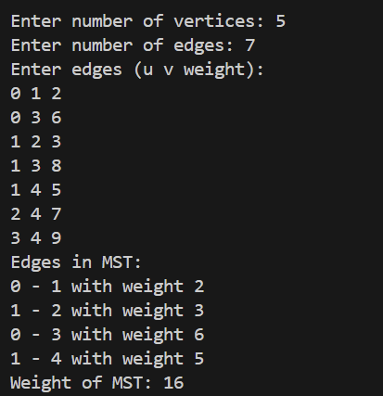

6)
#include <iostream>
using namespace std;

#define INF 99999

class Graph {
public:
int V;
int **adjMatrix;

Graph(int V) {
this->V = V;
adjMatrix = new int*[V];
for (int i = 0; i < V; i++) {
adjMatrix[i] = new int[V];
for (int j = 0; j < V; j++) {
adjMatrix[i][j] = INF;
}
}
}

void addEdge(int u, int v, int weight) {
adjMatrix[u][v] = weight;
adjMatrix[v][u] = weight;
}

void dijkstra(int start) {
int *dist = new int[V];
bool *visited = new bool[V];

for (int i = 0; i < V; i++) {
dist[i] = INF;
visited[i] = false;
}

dist[start] = 0;

for (int count = 0; count < V - 1; count++) {
int u = -1;
for (int v = 0; v < V; v++) {
if (!visited[v] && (u == -1 || dist[v] < dist[u])) {
u = v;
}
}
visited[u] = true;

for (int v = 0; v < V; v++) {
if (adjMatrix[u][v] != INF && !visited[v] && dist[u] + adjMatrix[u][v] < dist[v]) {
dist[v] = dist[u] + adjMatrix[u][v];
}
}
}

cout << "Vertex\tDistance from Source " << start << endl;
for (int i = 0; i < V; i++) {
cout << i << "\t" << dist[i] << endl;
}
}
};

int main() {
int V, E;
cout << "Enter number of vertices: ";
cin >> V;
cout << "Enter number of edges: ";
cin >> E;

Graph g(V);

cout << "Enter edges (u v weight): " << endl;
for (int i = 0; i < E; i++) {
int u, v, weight;
cin >> u >> v >> weight;
g.addEdge(u, v, weight);
}
int start;
cout << "Enter the starting vertex: ";
cin >> start;
g.dijkstra(start);
return 0;
}
